**Biology STAAR Review Stations**

**Day 2**

**Category #1 Cell Structure and Processes (5.A, 5.B, 5.C, 5.D)**

5.A describe the stages of the cell cycle, including deoxyribonucleic acid (DNA) replication and mitosis, and the importance of the cell cycle to the growth of organisms;

5.B examine specialized cells, including roots, stems, and leaves of plants; and animal cells such as blood, muscle, and epithelium;

5.C describe the roles of DNA, ribonucleic acid (RNA), and environmental factors in cell differentiation;

5.D recognize that disruptions of the cell cycle lead to diseases such as cancer.

**5.A, 5.B, 5.C, 5.D Pre-Test Score__________ Focus TEKS__________**

|  |  |  |  |  |
| --- | --- | --- | --- | --- |
|  | **5.A** | **5.B** | **5.C** | **5.D** |
| **Interactive Quizzes** | **Mitosis and Cytokinesis**  <http://glencoe.mcgraw-hill.com/sites/0078802849/student_view0/unit2/chapter9/section2/self-check_quizzes-english.html> | **Plant and Animal Cells**  <http://www.proprofs.com/quiz-school/story.php?title=plant-and-animal-cells-quiz_1> | **Cellular Reproduction**  <http://glencoe.mheducation.com/sites/0078802849/student_view0/unit2/chapter9/chapter_test_practice-english.html> | |
| **Graphic Organizers** | **Cell Cycle and Mitosis Graphic Organizer**  See handout | **Plant Specialized Cell Foldable**  See handout | **Cell Cycle Regulation Concept Map**  [**http://www.classzone.com/cz/books/bio_09/resources/htmls/interactive_review/bio_intrev_ch05.html**](http://www.classzone.com/cz/books/bio_09/resources/htmls/interactive_review/bio_intrev_ch05.html)  See handout | |
| **Virtual Labs** | **Determining time spent in different phases of the cell cycle**  [**http://www.biology.arizona.edu/cell_bio/activities/cell_cycle/cell_cycle.html**](http://www.biology.arizona.edu/cell_bio/activities/cell_cycle/cell_cycle.html) | **Virtual Stem Cell Lab**  <http://virtualstemlab.com/stemcell.html> | | **Virtual Lab: Cell Reproduction**  [**http://glencoe.mcgraw-hill.com/sites/dl/free/0078802849/383933/BL_23.html**](http://glencoe.mcgraw-hill.com/sites/dl/free/0078802849/383933/BL_23.html) |
| **Vocabulary** | **Cell Cycle Flashcards**  [**http://quizlet.com/8674960/cell-cycle-flashcards-flash-cards/**](http://quizlet.com/8674960/cell-cycle-flashcards-flash-cards/) | **Specialized Cells Flashcards**  <http://quizlet.com/5857764/specialized-cells-flash-cards/> | **Cell Differentiation Vocabulary**  **See handout** | **Disruptions to the Cell Cycle Picture Vocabulary**  **See handout** |
| **Video Clips** | **Cell Cycle Video**  <http://www.educreations.com/lesson/view/cell-cycle-b5a/2385579/?s=hTlM8x&ref=appemail> | **Cell Specialization Brain Pop Video**  <http://glencoe.mcgraw-hill.com/sites/dl/free/0078802849/164155/00035805.html>  **Specialized Cells and Tissues Video**  <http://www.youtube.com/watch?v=I8uXewS9dJU> | **Why RNA is Just as Cool as DNA**  <http://www.youtube.com/watch?v=0Elo-zX1k8M> | **The Cell Cycle and Cancer**  [**http://www.youtube.com/watch?v=lpAa4TWjHQ4&feature=youtu.be**](http://www.youtube.com/watch?v=lpAa4TWjHQ4&feature=youtu.be) |

**5.A, 5.B, 5.C, 5.D Post-Test Score__________**

**Notes:**

**5.A, 5.B, 5.C, 5.D Critical Thinking Questions**

1. How does mitosis compare to meiosis?
2. What are the characteristic changes of mitosis?
3. What are the characteristic changes in meiosis?
4. How are cells specialized to carry on their function? Why are all cells not the same?
5. What is the composition of DNA?

6. How is genetic information carried by DNA?

1. Discuss how a cell may become cancerous.

**5.B Plant Specialized Cell Foldable**

Use the online lecture link for assistance:

<http://www.mhhe.com/biosci/genbio/maderinquiry/lecture/lecture9.html>

Fold line Fold line

|  |  |  |
| --- | --- | --- |
| **Plant Structure** | **Function** | **Illustration** |
| Leaves |  |  |
| Stems |  |  |
| Xylem |  |  |
| Phloem |  |  |
| Roots |  |  |
| Flowers |  |  |

**5.C, 5.D Cell Cycle Regulation Concept Map**

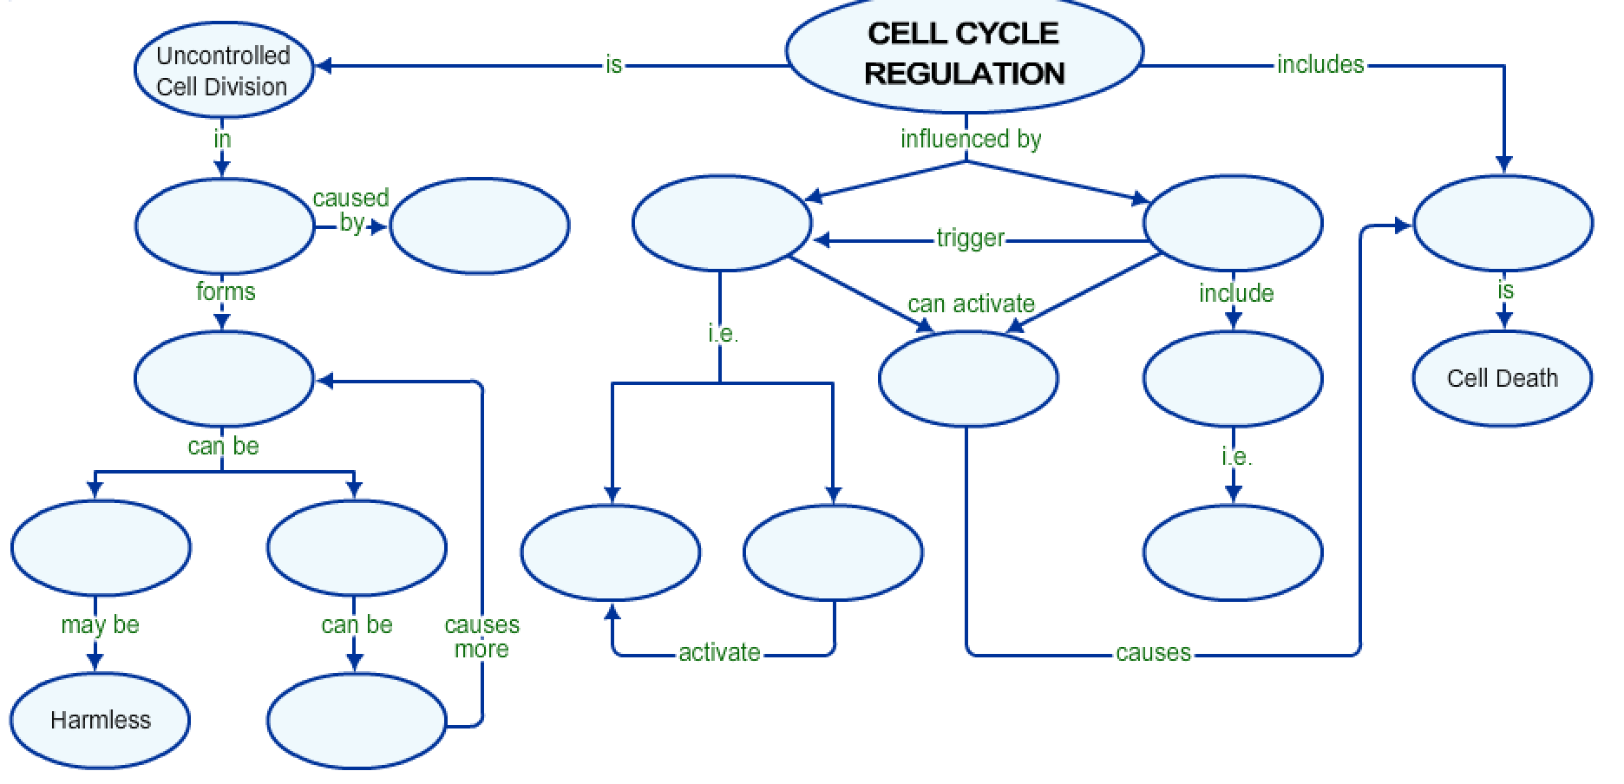

Word Bank

Cancer

Apoptosis

External Factors

Internal Factors

Cyclins

Metastasized

Carcinogens

Tumors

Self Destructive Enzymes

Messages

Growth Factors

Kinases

Malignant

Benign

**5.A Cell Cycle and Mitosis Graphic Organizer**

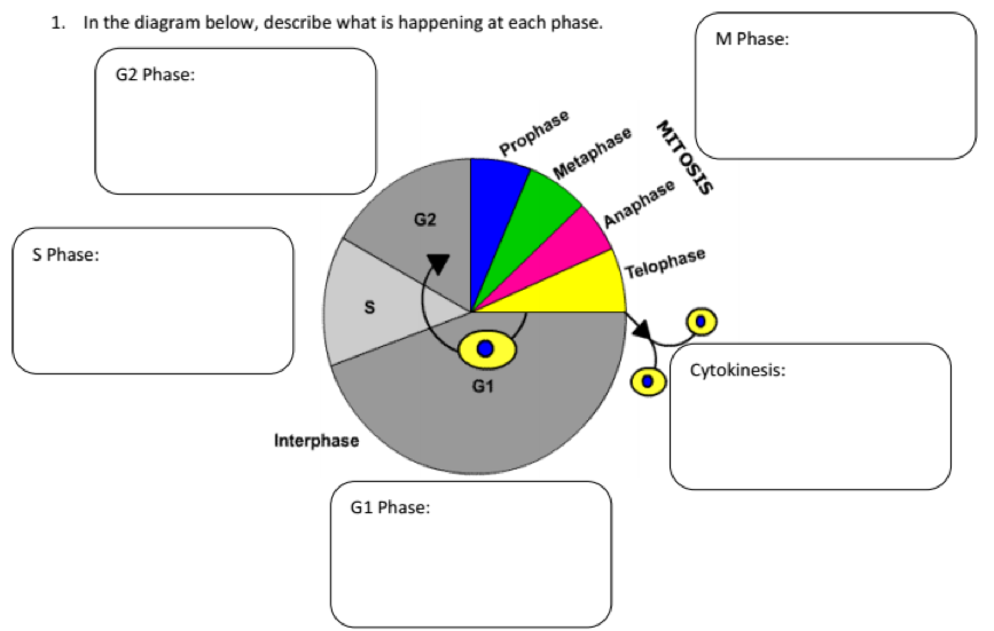

Match the appropriate pictures to the correct phase of mitosis

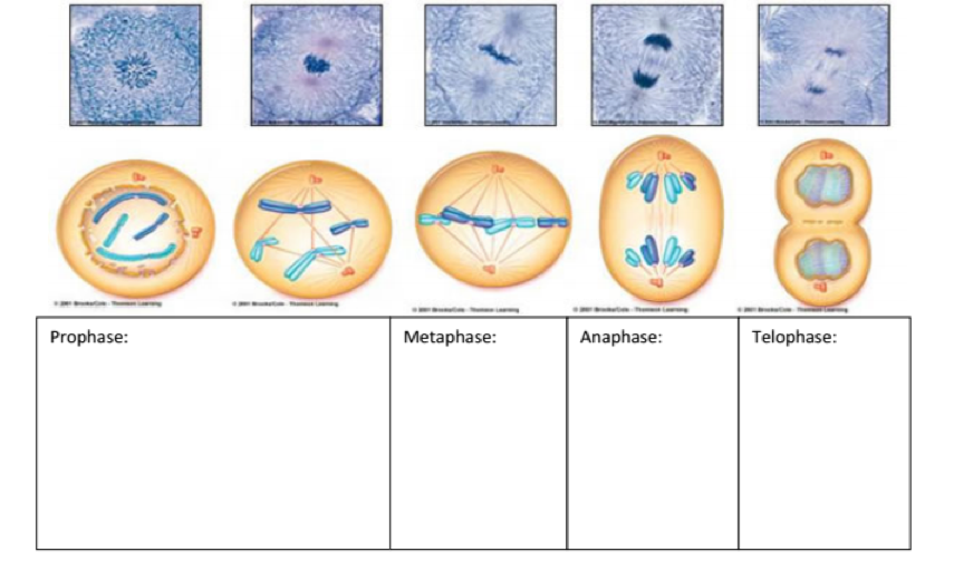

**5.C** **Cell Differentiation Vocabulary**

|  |  |
| --- | --- |
| **Cell differentiation** | The process of generic embryonic cells becoming specialized cells. |
| **Gene expression** | The specific combination of genes that are turned on or off (**expressed** or **repressed**), and this is what dictates how a cell functions. |
| **Importance of cell differentiation** | Cells need to have different structures because they have different functions |
| **DNA replication** | The process in which the DNA sequence is  copied to form an additional DNA molecule |
| **Stem Cell** | A “blank” cell that can be turned into a variety of different types of cells found in the body |
| **RNA** | The biomolecule classified as a nucleic  acid and composed of nucleotides; genetic  material in a single helix form |
| **Mutation** | Any change in the sequence of DNA; may result in the production of incorrect proteins and lead to malfunctions in the processes of the organism |

5.D Disruptions to the Cell Cycle Picture Vocabulary

Radiation 

Energy sent out as particles or

waves; used in the treatment of

cancerous tumors

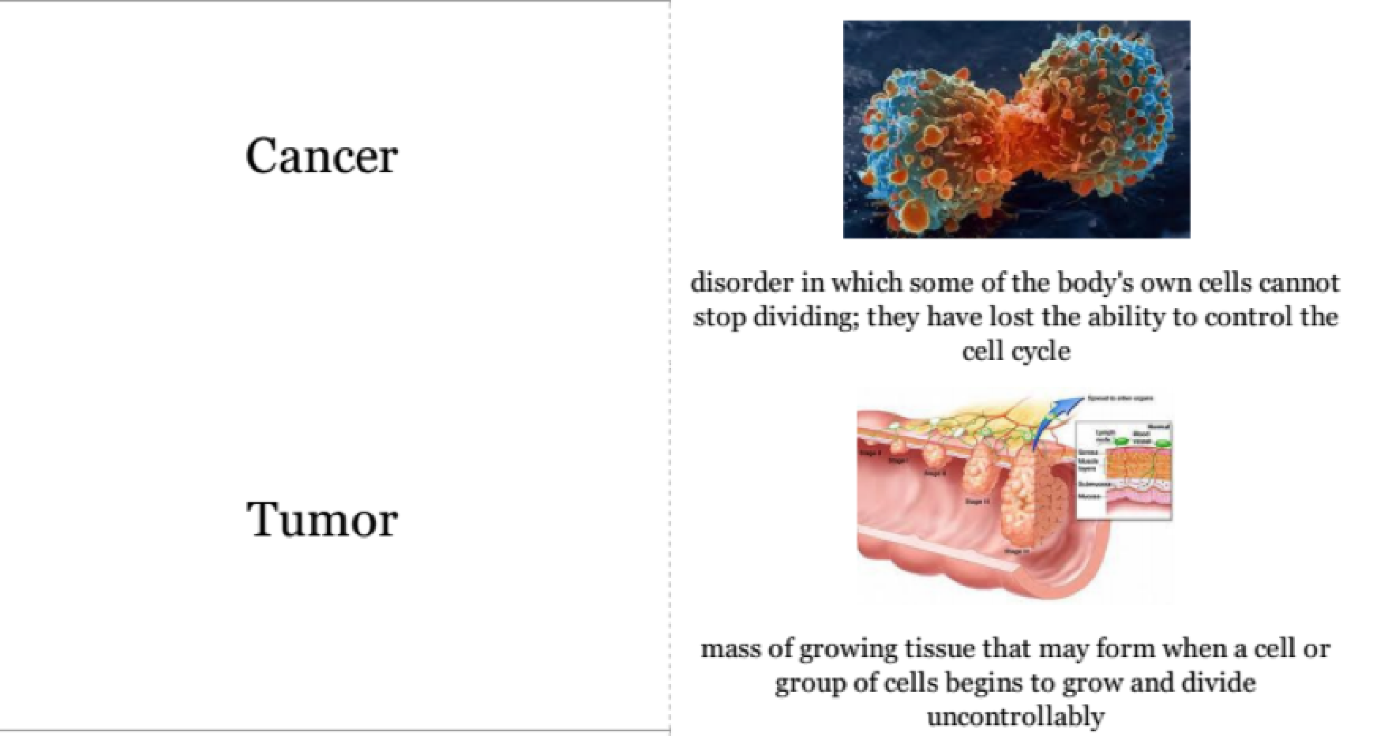

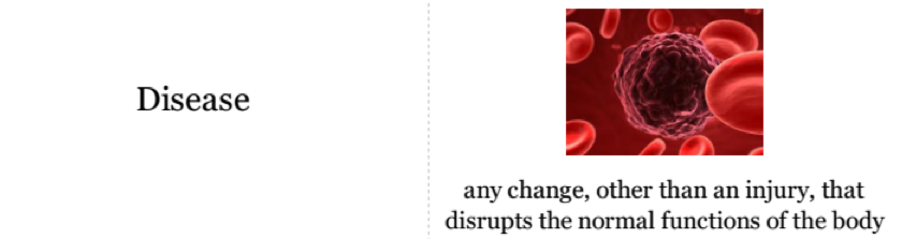

Chemotherapy 

The treatment of disease by use of chemicals; can selectively destroy cancerous tissue

**Day 2 Review Questions 5.A, 5.B, 5.C, 5.D**

5.A

_____1. What is the primary function of mitosis during the cell cycle?

a. phagocytosishttp://glencoe.mheducation.com/olcweb/styles/shared/spacer.gif

b. DNA replicationhttp://glencoe.mheducation.com/olcweb/styles/shared/spacer.gif

c. osmosishttp://glencoe.mheducation.com/olcweb/styles/shared/spacer.gif

d. separation of replicated DNA

**Michelle is looking through a microscope at an epithelial cell. She sees a cell that is in the process of dividing to make a new cell. This is what Michelle sees:**



5.A

_____2. Study the diagram and the description above. What is the name for the **process** Michelle is observing?

a. mutation

b. meiosis

c. mitosis

d. metamorphosis

5.A

_____3. Which of these statements about **cell division** is ***true***?

a. A newly formed daughter cell has less DNA than its parent cell.

b. Cells divide at random times.

c. New cells formed by cell division can replace dying cells in an organism.

d. The phases of cell division can occur in any order.

5.A  
_____4. What typically results from one completed cell cycle?

**a.** tissuehttp://glencoe.mheducation.com/olcweb/styles/shared/spacer.gif

**b.** dead cellhttp://glencoe.mheducation.com/olcweb/styles/shared/spacer.gif

c. new cellhttp://glencoe.mheducation.com/olcweb/styles/shared/spacer.gif

**d.** genome

5.B

_____5. What does this indicate about stem cells?

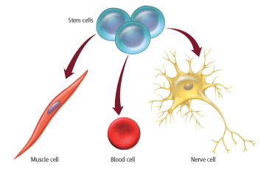

a. They cannot divide.http://glencoe.mheducation.com/olcweb/styles/shared/spacer.gif

b. They are preset to be one kind of cell.http://glencoe.mheducation.com/olcweb/styles/shared/spacer.gif

c. They cannot form a nerve cell.http://glencoe.mheducation.com/olcweb/styles/shared/spacer.gif

d. They become specialized cells.

5.B

_____6. Organisms as different as bacteria, mushrooms, algae, oak trees, and human beings are all made of cells. Which statement is true for all cells?

a. All cells have the same shape

1. All cells need energy to survive
2. All cells are surrounded by a rigid wall
3. All cells belong to organ systems

**5.B**

_____7. What is the **most likely function** of a group of cells that contain a **high number of chloroplasts**?

a. respiration

b. transpiration

c. fermentation

d. photosynthesis

5.B

_____8. Why do stem cells have potential for future medical advancements?

a. They only exist theoretically.http://glencoe.mheducation.com/olcweb/styles/shared/spacer.gif

b. They have unspecified functions.http://glencoe.mheducation.com/olcweb/styles/shared/spacer.gif

c. They are produced late in an organism's life.http://glencoe.mheducation.com/olcweb/styles/shared/spacer.gif

d. They cannot divide.

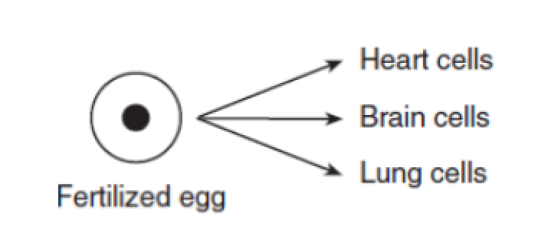

5.C

_____9. Which statement describes the diagram?

1. only the fertilized egg contains DNA and the tissue cells do not
2. cells in fertilized eggs are directed by DNA to become many types of cells
3. the DNA in fertilized eggs are different than that of cells of organs
4. heart, brain, and lung cells are the only types of cells fertilized eggs produce

5.C

_____10. Unicellular organisms carry out all the necessary life processes in one cell. In multicellular organisms, each cell is specialized to perform a specific function. How do the cells in multicellular organisms become specialized?

1. a single nucleus coordinates the function performed by each cell
2. individual cells carry unique sets of genes
3. the brain communicates the function required for each cell
4. cells develop specific functions through the expression of different genes as they mature

5.C

______11. The process of generic embryonic cells becoming specialized cells is called:

1. cell differentiation
2. gene expression
3. DNA expression
4. mitosis

5.C

_____12. The process of specific combinations of genes being turned on or off to dictate the functions of a cell:

1. cell differentiation
2. gene expression
3. DNA expression
4. mitosis

5.D

_____13. All forms of cancer are characterized by which of the following:

a. the inhibition of DNA replication

b. the aggregation of cells into a mass called a tumor

c. abnormal, unregulated production of cells

d. the spreading of abnormal cells across the body

5.D

_____14. Which of the following expresses how normal cells become cancer cells

a. regulation of cell growth and division is lost.

b. cells do not respond normally to control mechanisms.

c. cells continue to divide without passing through G1.

d. All of the above

5.D

A scientist studying cancer collected data from various types of cells, which is shown in the following graph:

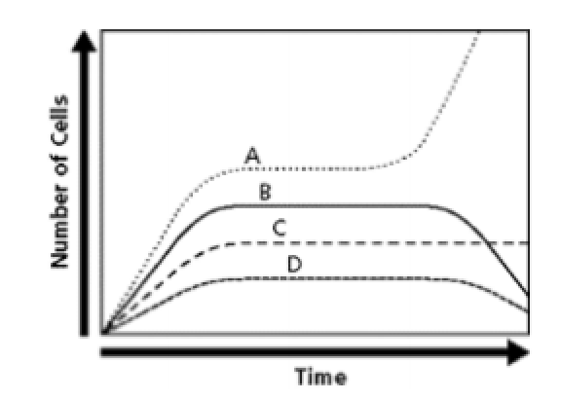

_____15. Which statement explains why A depicts cancerous cells?

1. cancer cells stop dividing when they become too tightly packed
2. cancer cells are unable to synthesize their own DNA
3. cancer cells have experienced a disruption of the cell cycle and cannot control cell division
4. cancer cells have begun to die off

http://glencoe.mheducation.com/olcweb/styles/shared/spacer.gif5.D

_____16. What conclusion can be made about the condition shown in this picture?

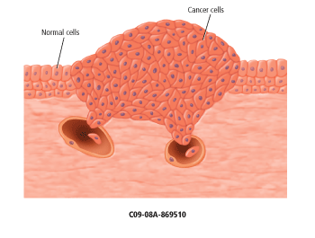

1. it was not caused by a mutation
2. it can only occur in an older organism
3. It cannot be caused by a carcinogen.
4. It was caused by abnormal cell replication.

**Day Two Review Questions (5.A, 5.B, 5.C, 5.D)**

**Answer Sheet**

**_____1.**

**_____2.**

**_____3.**

**_____4.**

**5.A Score__________/4**

**_____5.**

**_____6.**

**_____7.**

**_____8.**

**5.B Score__________/4**

**_____9.**

**_____10.**

**_____11.**

**_____12.**

**5.C Score__________/4**

**_____13.**

**_____14.**

**_____15.**

**_____16.**

**5.D Score__________/4**

**Day Two Review Questions (5.A, 5.B, 5.C, 5.D)**

**Key**

**__B__1.**

**__C__2.**

**__C__3.**

**__C__4.**

**__D__5.**

**__B__6.**

**__D__7.**

**__B__8.**

**__B__9.**

**__D__10.**

**__A__11.**

**__B__12.**

**_ C__ 13.**

**__D__14.**

**__C_ 15.**

**__D 16.**